Abstract

Machine learning, especially deep learning, is becoming popular in biological and medical fields. However, even though a large amount of data is produced within these fields, due to privacy issues, the implementation of machine learning still faces the problem of lacking suitable datasets. A new machine learning setting called Federated learning is considered to have the ability to utilize small and private datasets without the leakage in privacy, providing more potential opportunities for future researches.

In this project, we test federated learning under various scenarios using the CIFAR10 dataset. We also provide an example of a federated diabetic retinopathy detection task on the cloud. We hope this work can be a reference for bioinformaticians who want to attempt on federated settings in their researches.

Learning without sharing

Popular Science Summary

Jiarong Liang

Nowadays, biological or medical researchers have produced a large amount of data, which seems to be a perfect application field for machine learning. Machine learning, especially deep learning is becoming more and more popular in biological fields. In many cases, the researcher will ’teach’ a computer-based model to handle certain tasks using large and suitable datasets. These datasets can be found in various public databases. Many interesting attempts have already been done in developing drugs, assisting doctors, predicting epidemics, and so on.

However, in many other cases, researches are hindered by lacking suitable datasets, since biological or medical records sometimes include sensitive information and are not allowed to be accessed by researchers. For example, patients’ medical records from the hospitals should not be visited by anyone else except for the doctors. In another example, the gene sequence from the individuals are client’s genetic privacy, sequencing companies are not allowed to share them with genetic labs. In other situations where private information can be deduced from the records, publicizing can also be dangerous and illegal.

We all know that for complex tasks, feeding in more data to the model can usually result in better performance. Unfortunately, a suitable amount of data is not always available in a single institution, especially for small instances. Since we cannot share these data, the datasets from small instances become somehow wasted.

A new method has been developed for avoiding such limitations in data usage. This method, which is called Federated learning, is published in 2016 and has already been used in the development of several applications such as the Google keyboard. This method can make good use of the client’s private datasets without having access to them. In this project, we will test this method’s performance under several possible scenarios, and perform an example of using this technique for disease detection.

Degree project in bioinformatics, 2020  
Examensarbete i bioinformatik 30 hp till masterexamen, 2020   
Biology Education Centre and Department of Information Technology, Uppsala University  
Supervisor: Andreas Hellander

Table of Contents

Abbreviations……………………………………………………………………………………………………1

1 Introduction 3

2 Background 4

2.1 Federated Learning 4

2.2 Simple Federated Process 4

2.3 Federated Algorithms 5

2.4 Pre-work in Federated Learning 5

2.5 Federated Frameworks 6

2.6 Communication tools 6

2.7 Future in Biological Fields 6

3 Dataset and methods 6

3.1 CIFAR-10 dataset 7

3.2 OIA-DDR dataset 7

3.3 Training designs 7

3.4 Scenarios testing 8

3.4.1 Simulation System 8

3.4.2 Pilot Tests 8

3.4.3 Default Simulation Settings 10

3.4.4 Model Poisoning 10

3.4.5 Data Dispersion 10

3.4.6 Delayed Update 10

3.4.7 Share data strategy 11

3.5 Cloud Implementation 11

4 Results 12

4.1 Scenarios testing 12

4.1.1 Model Poisoning 12

4.1.2 Data Dispersion 14

4.1.3 Delayed Update 14

4.1.4 Share data strategy 15

4.2 Cloud implementation 16

5 Discussion 17

6 Conclusion 18

7 Acknowledgment 18

8 References 19

9 Appendix - OIA-DDR dataset after pre-processing 21

10 Appendix – Samples used in Box plots 22

11 Appendix - Statistical Records 23

12 Appendix - Scenario testing results with 40k set 24

13 Appendix - Scenario testing results with 4k set 27

14 Appendix - Results for cloud implementation 31

Abbreviations

DR Diabetic Retinopathy

FedAvg Federated Averaging Algorithm

FedSGD Federated Stochastic Gradient Descent Algorithm

HTTP/2 Hypertext Transfer Protocol Version 2

IID Independent and Identically Distributed

RPC Remote Procedure Call

SMC Secure Multiparty Computation

TCP Transmission Control Protocol

Software Links

TensorFlow <https://www.tensorflow.org/>

gRPC <https://grpc.io/>

Project GitHub Repository

<https://github.com/Jiarong000/Thesis2020>

# Introduction

Machine learning methods have been applied to medical or biological researches for long. Traditional algorithms such as PCA, random forest, AdaBoost has been widely used (Benitez *et al.* 2011, Chen & Ishwaran 2012). In recent years, a subfield called deep learning is becoming popular. Traditional machine learning workflow requires manual preprocessing and feature extraction, while deep learning can learn features from raw data. (Angermueller *et al.* 2016) and (Jurtz *et al.* 2017) summarize deep learning’s application in regulatory genomics, biological image and sequence analysis. Besides these, many interesting works have been done in recent years. DeepVariant aims to detect genetic variants from sequencing data (Poplin *et al.* 2018). DeepSimulator attempts to generate some more realistic base calls for simulation experiments (Li Y *et al.* 2018). Autoencoder has also been applied for denoising scRNA-seq datasets (Eraslan *et al.* 2019). Though the results of machine learning still require careful assessments from professionals in the application fields, it has a huge advantage in data mining and assisting professionals.

There is a consensus that a large dataset is required for deep learning tasks, especially when the task is complex. ChestX-ray14 is the largest dataset of chest radiographs, which contains 112120 images from 30805 unique patients. CheXNeXt is trained over this dataset and claims to approximate expert’s performance (Rajpurkar *et al.* 2018). In another research, several structurally distinct antibacterial molecules have been discovered with the assistance of a model trained with an empirical dataset of size 2335 (Stokes *et al.* 2020). In many other cases, a suitable dataset can be collected from biological databases such as NCBI and EMBL or other specific databases such as TCGA and ICGC.

However, it is not always possible to collect an appropriate dataset. In many cases, datasets are small and unbalanced. In other cases, annotations are not suitable for the specific training task. Many institutes, for example, hospitals or sequencing companies, own a private dataset of their clients and have the ability to perform annotation. Due to privacy concerns and restrictions, this part of data is usually not allowed to be shared with other institutes or to the public, resulting in many small and isolated datasets.

A new machine learning setting called Federated learning is considered to have the potential of utilizing isolated datasets without leakage in personal privacy. In this project, we will test federated learning’s behavior under various scenarios and perform an example federated medical image classification task on the cloud. We hope this work can provide references for future federated designs and we provide a trivial example for understanding and building up a federated system.

There are several challenges in federated learning, including communication costs, security protection, statistical and system heterogeneity (Li T *et al.* 2019b). In this project, we will not put too much attention on communication or security issues.

# Background

## Federated Learning

Federated learning is a machine learning strategy where many clients can collaboratively train a model when their local dataset is inaccessible to each other. The system will be orchestrated by a central server, in which training results from clients are aggregated. Compared to centralized learning, it requires less storage or computational resources in the central server and most importantly, protects each client’s private data.

There are many domains of federated learning. Cross-device federated learning is implemented on a large number of small devices while cross-silo learning is for collaboration among institutions (Kairouz *et al.* 2019). From another aspect, in most training cases there will be horizontal federated learning where client datasets are partitioned by samples and share similar feature space. In this case, gradients or weights are aggregated. On the other hand, client datasets only share user space in vertical learning, in which intermediate results such as hidden layer’s representations are shared (Yang *et al.* 2019). Federated transfer-learning, applied when the intersection in both feature and user space is small, is also possible (Liu *et al.* 2018).

In most biological or medical use cases, cross-silo and horizontal federated learning will be performed among institutions. A successful case of brain tumor segmentation in federated settings has been reported (Sheller *et al.* 2018). Besides this case, federated settings are not popular in current biological researches.

## Simple Federated Process

When we are training a machine learning model, we aim to use its function later. The model should not be used for any purpose until it is evaluated and considered to be well-trained. Hence, a federated process contains two stages, the training stage and the application stage.

The training stage mainly contains several basic steps (Kairouz *et al.* 2019). The server will select clients who meet the requirement and broadcast model weights to the client. Then clients train the model with their local data and upload the information (i.e. weights, intermediate layers) to be aggregated. These steps will be repeated until training is finished. Additional techniques and methods are applied to control these steps and encrypt shared messages.

The application phase is like in central machine learning. The model will be published or kept private according to the agreement with the clients.

## Federated Algorithms

Federated Averaging (FedAvg) and Federated SGD (FedSGD) are basics for many optimization algorithms and are widely used. In FedAvg settings, client weights will be collected and averaged while in FedSGD settings, gradients will be collected. Many other optimization algorithms are developed for various purposes, (Kairouz *et al.* 2019) provides a summary of popular ones.

## Pre-work in Federated Learning

Many pieces of research are implemented on current challenges in federated learning includes communication cost, security protection, statistical and system heterogeneity (Li T *et al.* 2019b). The communication cost is usually a bottleneck for cross-device learning. To save the cost, compression schemes and multiple local updating can be introduced to the settings (Li T *et al.* 2019b). Privacy issues, such as retrieving information from two successive models, have solutions such as SMC, differential privacy and homomorphic encryption. These solutions are used in popular federated frameworks that support both deep learning and traditional machine learning. Other techniques such as blockchain, can also be integrated to make the system more secure (Passeratpalmbach *et al.* 2019).

Statistical heterogeneity (such as different sample distributions among nodes) can also cause performance degradation. Methods to solve this mainly aims to make local dataset less non-IID, including sharing a small set of data (Zhao *et al.* 2018) and augmenting local set towards IID (Jeong *et al.* 2018).

System heterogeneity is also common. In some scenarios, such as in cross-device learning, since it is not a usual case to wait for all devices ready at the same time, the system will train on only the available devices at each time. In other cases, nodes will not update in synchronous ways if some nodes are too slow to be waited for. These are compromises for real-world applications and probably can cause the system to act in slower ways than usual. However, we are still uncertain about the extent of this impact.

Surprisingly, even with multiple optimization methods available, we cannot summarize an overview of statistical or system heterogeneity’s impact on federated learning. Those impacts are tested mostly in limited scenarios as a comparison to the optimization methods. In different researches, the author may also use different datasets and evaluation standards. In (Kairouz *et al.* 2019) the authors purpose the mathematical method to calculate convergence rated for non-IID datasets, however, only for ideal cases and is just theoretical. This fact can make many people stay uncertain about the extent of each issue’s impact on their federated system. Intuition is important for designing a system, especially when it is impossible to make optimization in every aspect. In this project, we test several common issues in federated learning thoroughly, under several IID or non-IID circumstances, and with different amounts of data. We hope this work can be a clear and easy-to-understand reference for those who need to implement federated learning in the future.

## Federated Frameworks

In the Appendix of (Kairouz *et al.* 2019), several popular federated frameworks are summarized. TensorFlow Federated and PySyft provide tools for federated learning based on the widely used TensorFlow and PyTorch software. A platform called PyGrid is also under development, using PySyft as its basic library. However, by the end of May 2020, their official versions have not yet been released, several simulation functions are available.

Another software called Federated AI Technology Enabler (FATE) has been released in 2019. FATE already have enabled several functions in both traditional learning and deep learning.

## Communication tools

In a federated system, clients need to communicate with the server. Browsing their source code, TensorFlow Federated seems to use gRPC and an example in PySyft uses WebSocket. gRPC is a high-performance RPC framework with HTTP/2-based transport. WebSocket provides computer communication over a single TCP connection. In this project, we use gRPC for communication.

## Future in Biological Fields

As tools become more sophisticated and convenient, using machine learning techniques is becoming more and more convenient. Automated machine learning aims to assist non-experts to apply machine learning techniques in many aspects (Yao *et al.* 2018). Google’s AutoML (Real *et al.* 2020), AutoAugment (Cubuk *et al.* 2018), Swish (Ramachandran *et al.* 2017) are popular examples.

At the same time, federated frameworks such as FATE can provide secure federating experience for their users. In the foreseeable future, collaboratively training a model with data from different institutes might no longer be a difficult task for biological researchers.

# Dataset and methods

In this project, the CIFAR-10 dataset (Krizhevsky 2012) has been used for locally simulating different scenarios of federated learning, the OIA-DDR dataset (Li T *et al.* 2019a) has been used for implementing an example medical image classification task on the cloud. The models are not the state of the art in recent years, but they are sufficient for testing scenarios for federated learning.

Each simulation task has been tested for 1000 epochs (for centralized training) or global rounds (for federated learning) and the cloud implementation has been tested for 100 epochs/rounds. The code is written in Python3 and TensorFlow 2.0.1 is used.

## CIFAR-10 dataset

The CIFAR-10 dataset consists of 50,000 training images and 10,000 testing images of 10 balanced classes, each image is in color format and the size is 32x32 pixels.

## OIA-DDR dataset

The OIA-DDR dataset provides high-quality diabetic retinopathy (DR) images and annotations. The grading annotation labels the images to six classes: no DR, mild, moderate, severe, proliferative and ungradable. In this project, we neglect images from the ‘ungradable’ class, using 6266 images from ‘no DR’ class as healthy samples and 6256 images from the rest 4 classes as DR samples.

Images in this dataset are in different sizes and qualities. We preprocess the images using the methods from public kernels on Kaggle, crop and resize them to 224x224 pixels.

In our implementation, we select 10000 balanced samples and divide it into a slightly non-IID federate training set (assume there are a large and balanced client and 2 small and unbalanced clients). The rest 2521 samples are used for testing. An IID version of the training is also tested (which is an ideal scenario).

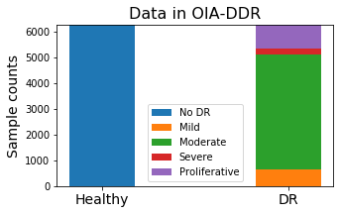 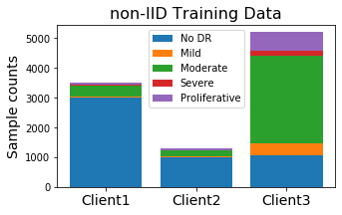

**Figure 1. Sample distribution. Left: Samples in OIA-DDR dataset. Right: Sample distribution in the non-IID training set.**

## Training designs

The task for CIFAR-10 is to input images of size 32x32x3 and classify them into 10 categories. The model is provided by Mattias Åkesson from Scaleout Systems. We apply the ADAM optimizer with the learning rate set to 1e-3. The batch size is set to 100 (or below 100 in tests with 4k dataset); the loss will be calculated by categorical cross-entropy.

The task for the OIA-DDR dataset is to input images of size 224x224x3 and classify them into 2 categories. VGG16 network (pre-trained on ImageNet dataset) is used. We apply the ADAM optimizer with the learning rate initialized at 1e-4 and decayed by rate 0.05 in every epoch or round. The batch size is set to 300; the loss will be calculated by binary cross-entropy.

learning_rate = 1e-4/(1+0.05*epoch_number)

## Scenarios testing

We simulate and test different scenarios in federated learning in this part. Due to the limit of time and computational resources, each test is performed only once.

### Simulation System

One central node and several client nodes are involved in this simulation system. We assume no data or nodes will be dropped out from or added into the system during the entire training process.

When the system starts, the central node will initialize a model. We apply Federated Averaging in this system, weighted by the size of the node. Each global round consists of the following basic actions:

1. Client nodes load weight from the central node,
2. Client nodes train the model over their local data and save the history,
3. Client nodes return weights to the central nodes,
4. The central node aggregates the weights and evaluates the model.

After the simulation, we collect the evaluation results in the central node’s folder as the overall testing history and average the node’s training history as the overall training history.

### Pilot Tests

Before the formal implementation of scenario testing, we test the system with various sizes of datasets and various IID or non-IID classes. Figure 2 compares centralized and federated learning’s behavior with various sizes of the training dataset. The result may fluctuate due to randomness, but it is obvious that the performance of both federated and centralized learning can be improved with the larger training set, and federated learning always acting at a slower speed than the centralized learning.

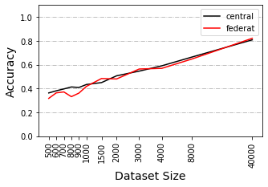 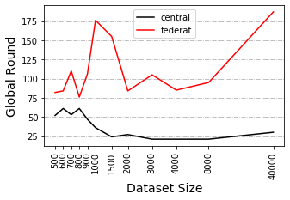

**Figure 2. The test is performed under IID circumstance for 500 epochs and Manipulations are implemented on windowed accuracy and loss (window size equals to 21). Left: Accuracy at minimal loss under various dataset size. Right: Round index at the minimal loss under various dataset size.**

In previous works, we already know that a non-IID training set can result in performance degradation in federated learning. We present the skew in label distribution simply by the available classes in each node. Figure 3 shows federated learning at different non-IID levels. It is obvious that accuracy and speed will decrease when the degree of non-IID increases.

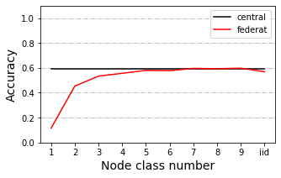 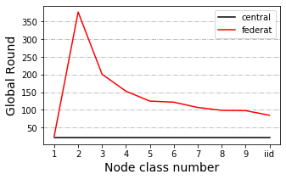

**Figure 3. Test records with the dataset of size 4000 for 500 epochs. Manipulations are implemented on windowed accuracy and loss (window size equals to 21). Left: Accuracy at minimal loss under various IID or non-IID circumstances. Right: Round index at minimal loss under various IID or non-IID circumstances.**

We also have observed a weird trend when testing between dataset of size 4000 and 40000 under 2 class non-IID circumstances. In other circumstances, training with the larger dataset always results in higher accuracy, while in this circumstance the trend is inverted. This inverted trend is also detectable in other 2 class and IID circumstances, indicating a possibility that training with the larger dataset can be influenced more when the system is seriously non-IID.

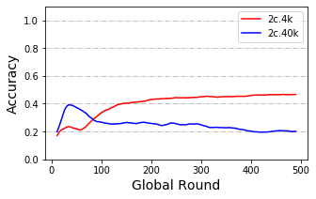

**Figure 4. Test record of training with the dataset of size 4000 and 40000 under 2 class non-IID circumstance. Manipulations are implemented on windowed accuracy and loss (window size equals to 21).**

### Default Simulation Settings

We select a balanced total training set of size 4000 or 40000 and apply evaluation with CIFAR10’s whole testing set. The training set is distributed to 10 or 40 nodes depending on the experimental design. Client nodes are in equal size and samples from available classes within a node are balanced. By default, local epochs are set to 1, and global rounds are set to 1000. Evaluation is performed by the central node. In each scenario, we change 1 parameter and compare it to the one without that change.

Scenarios are tested under 2 class, 5 class and IID circumstances with the dataset of size 4000 (4k dataset) and under 2 class, 3 class, 5 class and IID circumstances with the dataset of size 40000 (40k dataset). Early stopping of 500 rounds has been applied to testing with the 4k dataset.

### Model Poisoning

We test this scenario where there is an abnormal node that returns arbitrary weights at each global round. We split the training set to 10 nodes and added an abnormal node that claims to be 1% or 10% as large as the total training dataset.

Testing is performed with both 4k and 40k dataset. Additional tests of 3% abnormal node size are performed with the 40k dataset. Other additional tests of poisoning frequency and poisoning data are performed with the 40k dataset under IID condition.

### Data Dispersion

In some tests, we distribute our data to 10 clients, in other tests to 40 clients. In this scenario, we compare the training performance between 10 clients and 40 client cases in default settings. Testing is performed with both 4k and 40k dataset.

### Delayed Update

In this scenario, some nodes update at a slower speed than others. We split the training set to 40 nodes and test the situation from 2 aspects. Testing is performed with both 4k and 40k dataset.

From the first aspect, we test various proportion of delayed nodes. 20%, 50% and 80% (with 4k dataset) or 25%, 50% and 75% (with 40k dataset) of nodes are delayed, they load the weights at global round n, and upload the weights at global round n+3. New weights won’t be loaded until current weights are uploaded.

From the second aspect, we test various speeds of delayed nodes: 20% of nodes are delayed (with both 4k and 40k dataset), they load the weights at global round n, and upload the weights at global round n+3, n+12 or n+30. New weights won’t be loaded until current weights are uploaded.

### Share data strategy

In previous tests, 1 class non-IID never behaves better than random. Research suggests a data-sharing strategy that can improve the training performance over 1 class non-IID data (Zhao *et al.* 2018). The author assumes a small IID set (2.5% to 25% as large as total training dataset) can be published for pre-training the model or sharing between nodes.

In this scenario, we attempt to 3 different methods of using the shared data. Testing is performed with the 4k dataset and sharing amount as large as 2.5% as the total testing set. To save time, we tested only with 1 class and 5 class non-IID circumstances for 200 rounds.

Using this strategy, after receiving the shared data, each client node will contain a mixed sample pool of shared and local data. Method 1 is the direct usage of the entire pool. Method 2 will under-sample a balanced subset from the pool (using ’ RandomUnderSampler’ from the ’ imblearn’ package). Method 3 will oversample the pool (we test both ’ SMOTENC’ and ’ ADASYN’ from the ’ imblearn’ package).

## Cloud Implementation

In the cloud implementation experiment, our synchronous gRPC system consists of 1 central server and 3 clients. The clients join in the training by sending a request to the server by every round. The server knows it will have 3 clients; aggregation will start when 3 returned weights are received. Each global round consists of the following basic actions (from the server’s side):

1. The server initializes the model and saves the weight,
2. The server receives requests,
3. Server register clients and send weights,
4. (Clients perform local training),
5. Server receive returned weights, wait until 3 weights are ready,
6. The server aggregates weights and performs an evaluation.

As we mentioned before, an IID and a slightly non-IID dataset are prepared for this task. We also test the centralized training performance with the total training test and the largest federated subset.

# Results

## Scenarios testing

In an ideal training process, the best accuracy and minimal loss will be achieved at the convergence epoch. In our training, we have observed a slight increase in accuracy after the loss reaches to its least, in which case the model starts to overfit the training data. Since our loss function is cross-entropy, this situation is possible, for example, when some samples are classified to more deviated predictions from correct results while slightly deviated predictions are corrected. In such cases, it is hard to tell if an increase in accuracy can represent the increase in performance. Also, other better models might be able to avoid this situation. Thus, we assume our model performs best at the global round with minimal loss, the accuracy at that round represents the model’s best performance. In our following plots, we will label this point by a colored square.

Since the original results have fluctuated, we show and manipulate on windowed testing accuracy and loss in this report, with window size equals to 21. In this section, we show statistical summaries or part of our testing results. The full and original records are available in the GitHub repository, including the accuracy and loss curve for both training and testing datasets. Also, we will append the windowed results at the end of the report.

### Model Poisoning

The presence of an abnormal node leads to performance degradation. The influence is related to both the size of the abnormal node and the poisoning frequency. We label the situation when an abnormal node which is as large as x% of the total training set and uploads arbitrary weight by every y rounds as ‘x%-y’. We observe similar accuracy trends among the situation ‘1%-1’, ‘3%-3’ and ‘10%-10’, while there is a huge difference among ‘1%-1’, ‘3%-1’ and ‘10%-1’ or ‘10%-1’ and ‘10%-10’. In the 3 similar situations, they have the same average abnormal node size per round. The influence of abnormal node size, in this case, might still exist. Loss of ‘10%-10’ stops decreasing at earlier rounds than ’1%-1’.

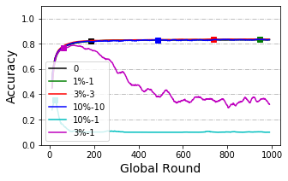

**Figure 5. Accuracy curve of model poisoning tested with 40k dataset under IID circumstance. The X-axis represents global rounds and Y-axis represents accuracy (window size equals 21). ‘0’ represents no poisoning to the system.**

Models trained with large dataset seems to have a higher tolerance to attacks from abnormal nodes. In the case of the 1% size abnormal node, we cannot observe performance degradation in model trained with an IID 40k dataset, while this degradation is obvious in models trained with 4k dataset. On the other hand, no obvious decrease pattern among non-IID groups has been observed. Though we have observed a slight decrease in non-IID groups (while there is no decrease in the IID group), the decrease does not appear much serious in 2 class than 5 class non-IID.

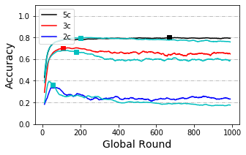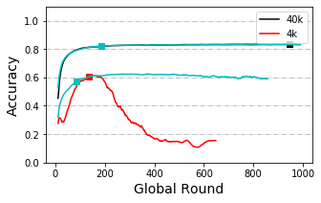

**Figure 6. Accuracy curve of model poisoning. The X-axis represents global rounds and Y-axis represents accuracy (window size equals 21). The light blue line without a label is the original curve without any poisoning for each case. Left: Poisoned by the abnormal node of size ‘1%’ by every round with 40k dataset, comparing between non-IID classes. Right: Poisoned by the abnormal node of size ‘1%’ by every round under IID circumstance, comparing between 4k and 40k dataset.**

In some other cases, abnormal nodes may upload training results over the dataset with the shuffled labels, which is called data poisoning. Testing results in data poisoning indicates that data poisoning is weaker than model poisoning.

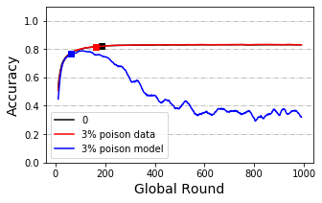

**Figure 7. Accuracy curve of data poisoning and model poisoning. The X-axis represents global rounds and Y-axis represents accuracy (window size equals 21). Poisoned by the abnormal node of size ‘3%’ by every round, tested with 40k dataset and under IID condition.**

### Data Dispersion

From Figure 8 below we can see training with 40 client nodes is slower than training with 10 client nodes while accuracy at minimal loss is not obviously affected. Statistical tests are applied and the results show a significant difference between speeds (p-value=0.0059). Differences in accuracy at minimal loss are not significant (p-value=0.71).

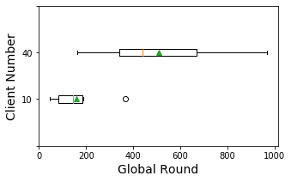 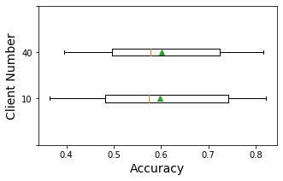

**Figure 8. Box plot of the round index (Left) and accuracy (right) where loss is the minimum, group by client number, including results tested with 4k and 40k dataset under various IIN and non-IID circumstances. Manipulations are performed on windowed testing accuracy and loss (window size equals to 21).**

### Delayed Update

Statistical tests are applied to detect the difference between no-delay-node cases and other situations. Statistical tests show a significance between with or without delayed nodes in the speed to reach minimal loss (round index) when delay speed is 3 and proportion between 20% to 25% (p-value=0.016). Surprisingly, this significance disappears as delay speed and proportion increases. On the other hand, when grouped by delay proportion, there is also no significance between group ‘<50’ and ‘50’ or ‘50’ and ‘>50’, making the trend of these two groups ambiguous.

When grouped by delay speed, a significance between group ‘3’ and ‘12’ has also been detected. Delayed nodes’ effect on the speed to reach minimal loss (round index) is very likely to be weakened when delay speed becomes larger.

Also, accuracy at minimal loss with delay proportion larger than 50 is reported to be significantly reduced (p-value=0.01 and 0.005). Change in delay speed does not obviously affect the accuracy at minimal loss.

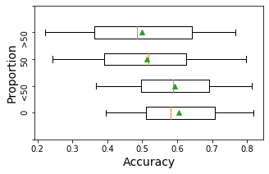 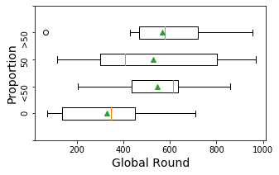

**Figure 9. Box plot of the round index (Left) and accuracy (right) where loss is minimum, group by the proportion of delayed nodes, including results for delay speed equals to 3, tested with 4k and 40k dataset and under various non-IID or IID conditions. Manipulations are performed on windowed testing accuracy and loss (window size equals to 21). ‘0’ means no delayed nodes in the system. ‘<50’ represents the delay proportion of 20% and 25% (for 4k and 40k dataset, respectively). ‘50’ represents the delay proportion of 50%. ‘>50’ represents the delay proportion of 75% and 80% (for 40k and 4k dataset, respectively).**

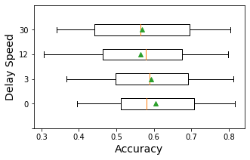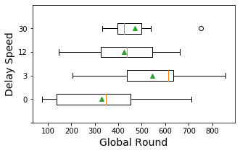

**Figure 10. Box plot of the round index (Left) and accuracy (right) where loss is minimum, group by delay speed, including results with 4k and 40k dataset when delay proportion equals to 20% or 25% (for 4k and 40k dataset, respectively). Tested under various non-IID or IID conditions. Manipulations are performed on windowed testing accuracy and loss (window size equals to 21).**

### Share data strategy

In this scenario, we compare different methods of using shared data. As we mentioned before, each client owns a mixed pool of local and shared data. When the shared amount is small (in this case, 2.5%), data in the pool is still unbalanced.

Figure 11 shows the results between directly using the mixed dataset and doing resample on the mixed dataset when sharing data is as large as 2.5% of the total dataset, tested with 4k dataset under 1 class and 5 class non-IID. Oversampling strategies seem to converge at a faster speed than the share-only method and under-sampling method. When data is seriously non-IID (the 1 class cases), all those methods perform better than without sharing but still cannot reach the accuracy level of the IID case. While the data is not seriously non-IID (the 5 class cases), share-only and oversampling methods only have a subtle influence on the accuracy curve, while the under-sampling method seems to have placed a negative influence on original accuracy.

Also, the oversampling methods we tested here require a large amount of computing. Considering the fact that the share-only method can be much convenient and have similar or even better results than the resampling ones, in our case, this method seems to be the best strategy of using shared data.

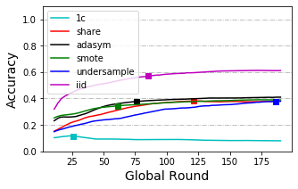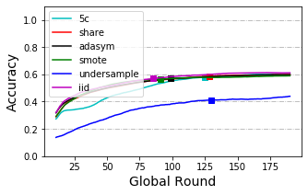

**Figure 11. Accuracy curve of share data strategies compared to the IID curve and the original curve. The X-axis represents global rounds and Y-axis represents accuracy (window size equals 21), testing with 4k training set and 2.5 % shared set. Left: Results for 1 class non-IID circumstance. Right: Results for 5 class non-IID circumstances.**

## Cloud implementation

We have successfully performed our example task on the cloud. Similar as in simulation with CIFAR10, slightly non-IID and IID federated set behaves similarly. They perform worse than centralized training but better than training with the largest subset. Note that in Figure 12 we zoomed the Y-axis to show a much clearer difference, the results in the original scale are available in the Appendix.

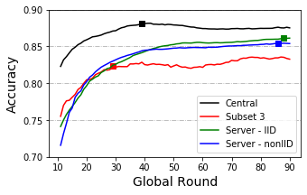

**Figure 12. Accuracy curve of implementations with OIA-DDR dataset for 200 epochs. The X-axis represents global rounds and Y-axis represents accuracy (window size equals 21).**

# Discussion

From previous researches, we already know that model or data poisoning can result in performance reduction and many defense methods have been suggested for this issue (Kairouz *et al.* 2019). But we have not found a test to compare this effect in different training scenarios. In our testing, we have observed that model poisoned by the same average strength per round (‘1%-1’, ’3%-3’ and ‘10%-10’) have similar behavior. We have also observed a stronger resistance to model poisoning when training with a larger dataset and we show a weaker effect of data poisoning. These results may indicate that when defense methods are not working for our system and checking at every round is too costly, we can reduce the checking frequency for very small or slow nodes since the system is comparatively less affected in slight or low-frequency attacks.

In testing with the delayed update, we have observed the system acting slower when the delay happened. This decrease in speed seems to be reduced when delay speed increases. A possible explanation of this is that delayed nodes of larger speed upload their weights at a lower frequency than others. Due to the ambiguous statistical results, we are still uncertain about the larger delay proportion’s effect on speed to reach minimal loss. The situation of ‘>50’ can be viewed as some small proportion of nodes acting at a faster speed than the others, while the rest of the system is 3 times slower than the original one. Logically, the overall system should act slower, but we cannot make a conclusion from our current results.

We have observed a decrease in accuracy when delay proportion is equal to or larger than 50%. The raise in delay speed does not obviously influence the final accuracy, possibly because the proportion of delayed node of this test is small. Considering its uploading frequency, we expect accuracy to be less affected when delay speed is increased since the weights from the delayed nodes can be viewed as slightly poisoned nodes. On the other hand, since data in the delayed part is not well trained, the system has less effective training data than usual, accuracy should be lower than usual. But these opinions need more testing. Our current results suggest that the majority of nodes should be synchronized when designing the federated system.

In the test with data dispersion, we detect no decrease in accuracy, thereby increasing the confidence of inviting small clients.

In the test with share data strategy, only when the training data is seriously non-IID, we found that the performance can be improved significantly by using shared data. We suggest using a share-only strategy in simple applications since it can be achieved in a much easier way and seems to have similar or better performance than the resampling methods. Current methods we used for oversampling fail to improve the share-only strategy, possibly because these methods are not specific for generating images. ADASYN and SMOTE generate new images pixel by pixel, using the information from the original samples. This is not a suitable method for generating images, since objects in original images may have different colors, shapes, positions, and so on. In the future, if there are more suitable oversampling tools developed for images, such as using suitable augmentation, the performance of non-IID systems may be significantly improved, even without sharing data. However, our current result cannot support this view. For people who have not much experience in such fields, share-only is always the most convenient method.

We also have thought about shifting evaluation methods to the clients. Ideally, if the clients can split part of local data as the testing set, aggregated evaluation results will be the same as collecting this testing set to the central. But in this case, we cannot evaluate the honesty of the clients. Thus, a valid centralized testing set is still a necessity for federated learning.

We successfully implemented a federated procedure on the cloud and get similar trends as in simulation tests. However, in this case, our weight size is around 80.6 Mb and the system contains only 3 clients. There might be some limitations in transporting size, though usually, deep learning models will not be that large. Another student in the Lab is focusing on communication research.

# Conclusion

We have tested several scenarios in federated learning under various circumstances, the results can provide an easy-to-understand reference to future federated designs. Our simulation system can also be edited for other scenario testings with tiny changes.

We also perform a trivial example of diabetic retinopathy detection on the cloud. Currently, we have not found many federated implementations in biological and medical fields. Our code can be an easy-to-understand example for bioinformatics or other people who would like to attempt on federate deep learning.

# Acknowledgment

I want to acknowledge suggestions and helps from my supervisor and subject reader and members in the lab. And Mattias Åkesson who provide the model and instructions for simulating federated learning.

# References

Angermueller C, P?Rnamaa T, Parts L, Stegle O. 2016. Deep learning for computational biology. Molecular Systems Biology 12: 878.

Benitez CMV, Chidambaram C, Hembecker F, Lopes HS. 2011. A Comparative Study of Machine Learning and Evolutionary Computation Approaches for Protein Secondary Structure Classification. InTech

Chen X, Ishwaran H. 2012. Random forests for genomic data analysis. Genomics 99:

Cubuk ED, Zoph B, Mane D, Vasudevan VK, Le QV. 2018. AutoAugment: Learning Augmentation Policies from Data. arXiv: Computer Vision and Pattern Recognition

Eraslan G, Simon LM, Mircea M, Mueller NS, Theis FJ. 2019. Single-cell RNA-seq denoising using a deep count autoencoder. Nature Communications 10: 390.

Jeong E, Oh S, Kim H, Park J, Bennis M, Kim S. 2018. Communication-Efficient On-Device Machine Learning: Federated Distillation and Augmentation under Non-IID Private Data. arXiv: Learning

Jurtz VI, Johansen AR, Nielsen M, Almagro Armenteros JJ, Nielsen H, Sønderby CK, Winther O, Sønderby SK. 2017. An introduction to deep learning on biological sequence data: examples and solutions. Bioinformatics 33: 3685–3690.

Kairouz P, Mcmahan HB, Avent B, Bellet A, Bennis M, Bhagoji AN, Bonawitz K, Charles Z, Cormode G, Cummings R, others. 2019. Advances and Open Problems in Federated Learning. arXiv: Learning

Krizhevsky A. 2012. Learning Multiple Layers of Features from Tiny Images. University of Toronto

Li T, Gao Y, Wang K, Guo S, Liu H, Kang H. 2019a. Diagnostic Assessment of Deep Learning Algorithms for Diabetic Retinopathy Screening. Information Sciences 501: 511–522.

Li T, Sahu AK, Talwalkar A, Smith V. 2019b. Federated Learning: Challenges, Methods, and Future Directions. arXiv: Learning

Li Y, Han R, Bi C, Li M, Wang S, Gao X. 2018. DeepSimulator: a deep simulator for Nanopore sequencing. Bioinformatics 34: 2899–2908.

Liu Y, Chen T, Yang Q. 2018. Secure Federated Transfer Learning. arXiv: Learning

Passeratpalmbach J, Farnan T, Miller RC, Gross MS, Flannery HL, Gleim B. 2019. A blockchain-orchestrated Federated Learning architecture for healthcare consortia. arXiv: Computers and Society

Poplin R, Chang P-C, Alexander D, Schwartz S, Colthurst T, Ku A, Newburger D, Dijamco J, Nguyen N, Afshar PT, Gross SS, Dorfman L, McLean CY, DePristo MA. 2018. A universal SNP and small-indel variant caller using deep neural networks. Nature Biotechnology 36: 983–987.

Rajpurkar P, Irvin J, Ball RL, Zhu K, Yang B, Mehta H, Duan T, Ding D, Bagul A, Langlotz CP, Patel BN, Yeom KW, Shpanskaya K, Blankenberg FG, Seekins J, Amrhein TJ, Mong DA, Halabi SS, Zucker EJ, Ng AY, Lungren MP. 2018. Deep learning for chest radiograph diagnosis: A retrospective comparison of the CheXNeXt algorithm to practicing radiologists. PLOS Medicine 15: 1–17.

Ramachandran P, Zoph B, Le QV. 2017. Swish: a Self-Gated Activation Function. arXiv: Neural and Evolutionary Computing

Real E, Liang C, So D, Le QV. 2020. AutoML-Zero: Evolving Machine Learning Algorithms From Scratch. arXiv: Learning

Sheller MJ, Reina GA, Edwards B, Martin J, Bakas S. 2018. Multi-Institutional Deep Learning Modeling Without Sharing Patient Data: A Feasibility Study on Brain Tumor Segmentation. arXiv: Learning

Stokes JM, Yang K, Swanson K, Jin W, Cubillos-Ruiz A, Donghia NM, MacNair CR, French S, Carfrae LA, Bloom-Ackermann Z, Tran VM, Chiappino-Pepe A, Badran AH, Andrews IW, Chory EJ, Church GM, Brown ED, Jaakkola TS, Barzilay R, Collins JJ. 2020. A Deep Learning Approach to Antibiotic Discovery. Cell 180: 688-702.e13.

Yang Q, Liu Y, Chen T, Tong Y. 2019. Federated Machine Learning: Concept and Applications. arXiv: Artificial Intelligence

Yao Q, Wang M, Escalante HJ, Guyon I, Hu Y, Li Y, Tu W, Yang Q, Yu Y. 2018. Taking Human out of Learning Applications: A Survey on Automated Machine Learning. arXiv: Artificial Intelligence

Zhao Y, Li M, Lai L, Suda N, Civin D, Chandra V. 2018. Federated learning with non-iid data. arXiv preprint arXiv:1806.00582

# Appendix - OIA-DDR dataset after pre-processing

Methods from (<https://www.kaggle.com/ratthachat/aptos-eye-preprocessing-in-diabetic-retinopathy>) and (<https://www.kaggle.com/titericz/circle-to-rectagle-preprocessing-1>) are used for preprocessing original images to our input data.

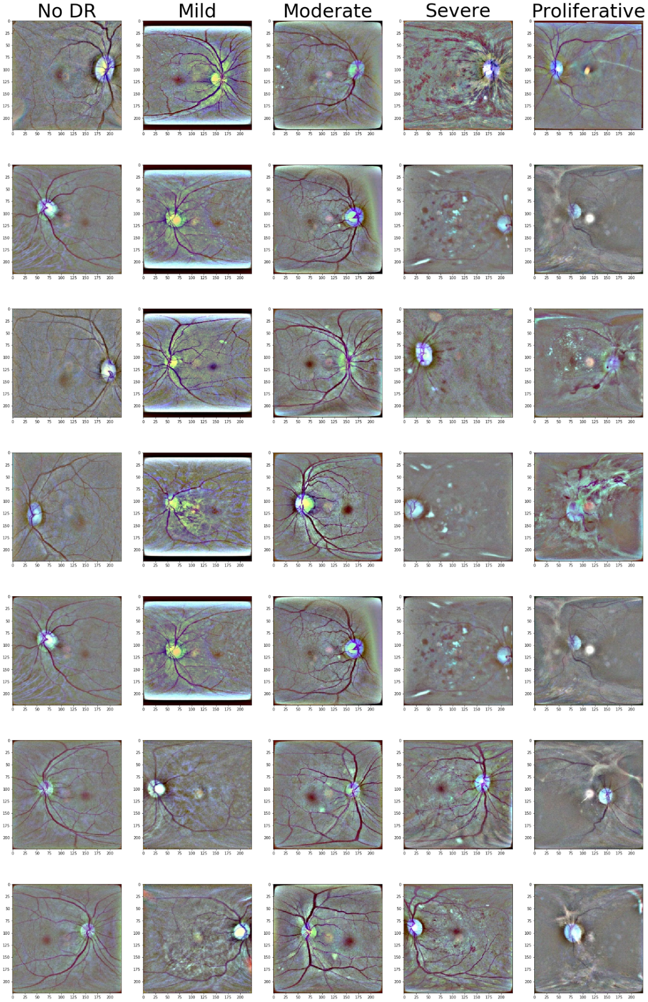

# Appendix – Samples used in Box plots

***Data Dispersion***

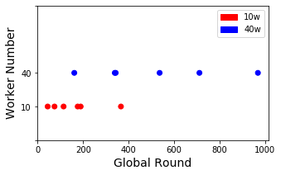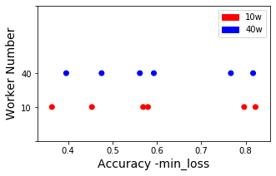

***Delayed Update***

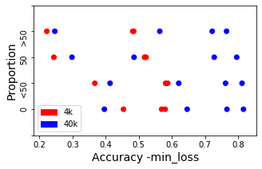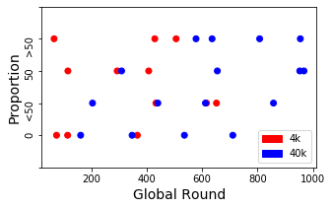

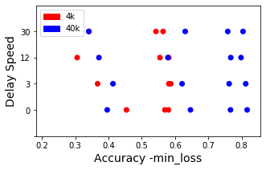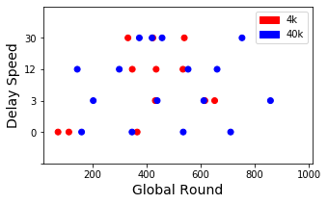

# Appendix - Statistical Records

In this Appendix, we record the results of statistical tests. Shapiro–Wilk test and Levene's test have been performed to assess normality and variance homogeneity, which is the pre-requirement of using the T-test. We perform the T-test or Wilcoxon test depending on assessing results. Results tested by the Wilcoxon test are tagged with ‘#’.

***Data Dispersion***

|  |  |
| --- | --- |
|  | ‘10w’-‘40w’ |
| ACC | 0.71 |
| Round | 0.0059 * |

***Delayed Update***

|  |  |  |  |  |  |  |
| --- | --- | --- | --- | --- | --- | --- |
| Proportion | ‘0’-‘<50’ | ‘<50’-‘50’ | ‘50’-‘>50’ | ‘0’-‘50’ | ‘0’-‘>50’ | ANOVA |
| Acc | 0.41 | 0.0041 * | 0.39 | 0.01 * | 0.005 * | 0.62 |
| Round | 0.016 * | 0.90 | 0.60 | 0.089 | 0.092 | 0.35 |

|  |  |  |  |  |  |  |
| --- | --- | --- | --- | --- | --- | --- |
| Delay Speed | ‘0’-‘3’ | ‘3’-‘12’ | ‘12’-‘30’ | ‘0’-‘12’ | ‘0’-‘30’ | ANOVA |
| Accuracy | 0.41 | 0.027 * | 0.77 | 0.11 | 0.052 | 0.97 |
| Round | 0.016 * | 0.014 * | 0.44 | 0.17 | 0.059 | 0.23 |

# Appendix - Scenario testing results with 40k set

***Model Poisoning – By Abnormal Node Size***

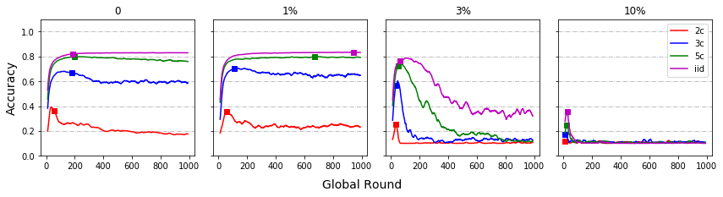

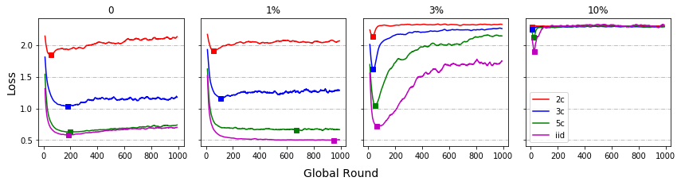

***Model Poisoning – By IID/non-IID***

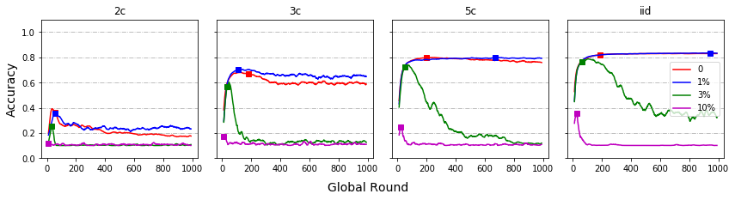

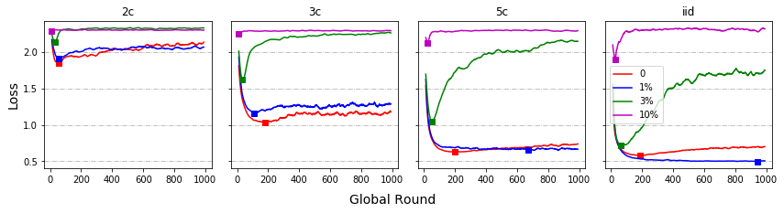

***Data Poisoning***

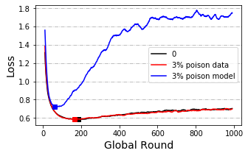

***Data Dispersion***

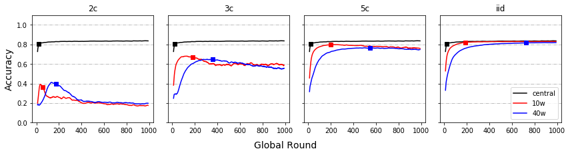

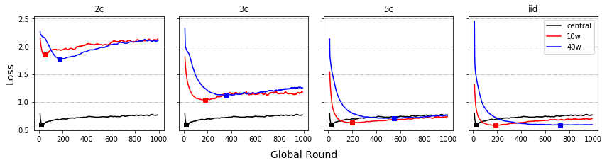

***Delayed Update – By Proportion***

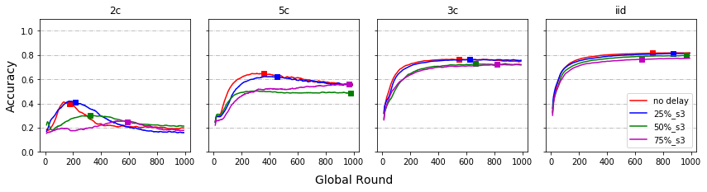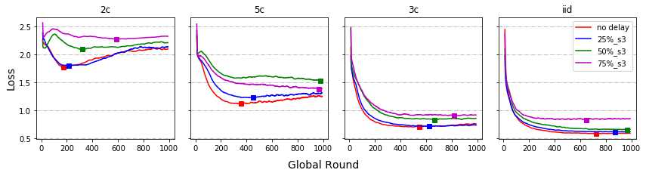

***Delayed Update – By Speed***

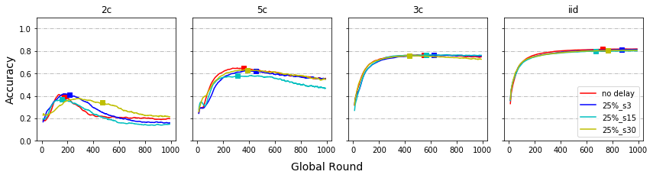

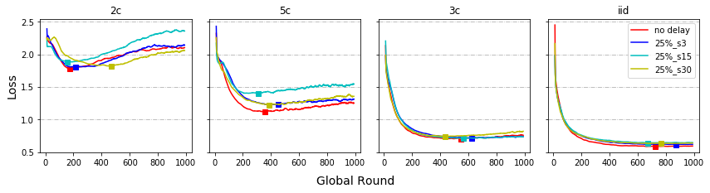

***Share data strategy (Additional)***

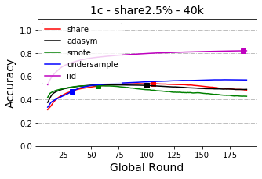 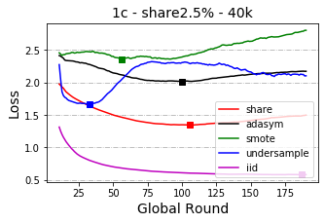

# Appendix - Scenario testing results with 4k set

***Model Poisoning – By Abnormal Node Size***

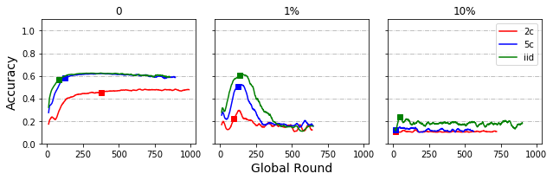

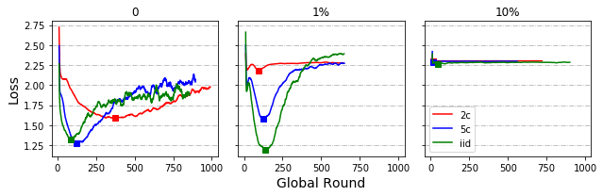

***Model Poisoning – By IID/non-IID***

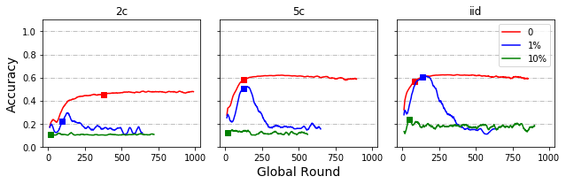

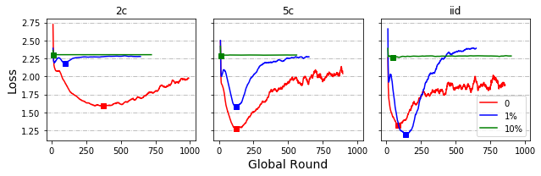

***Data Dispersion***

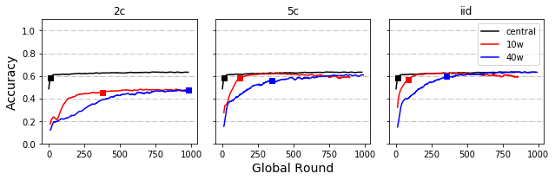

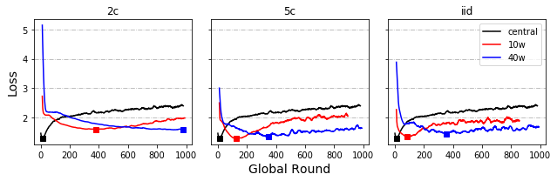

***Local Round (Additional)***

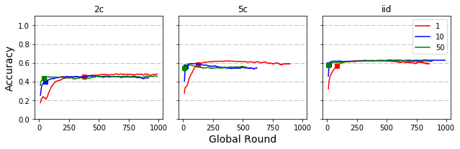

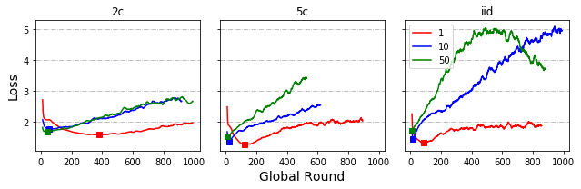

***Delayed Update – By Proportion***

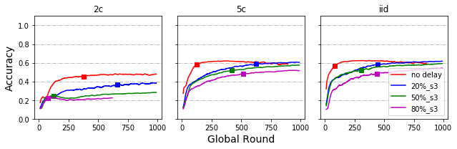

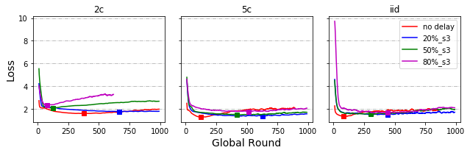

***Delayed Update – By Speed***

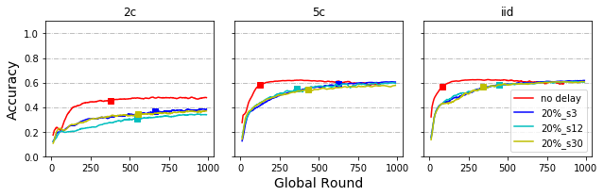

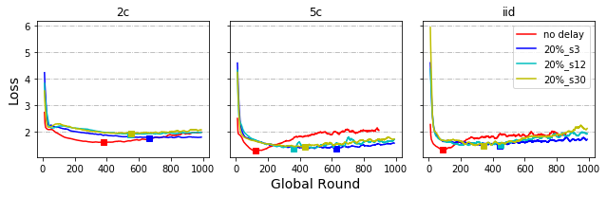

***Share data strategy***

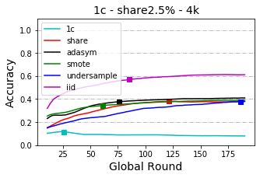 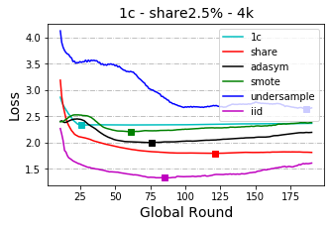

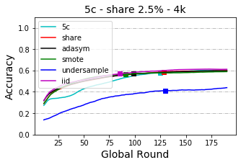 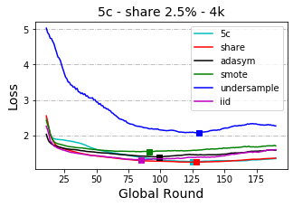

# Appendix - Results for cloud implementation

